

Develop a Payslip Generator Application

**Summary**

Developed application which takes input from the user and display output according to it.

**Must Steps:**

1. After cloning the code and automatic installation of package, do open task runner explorer and click on build and dev option.

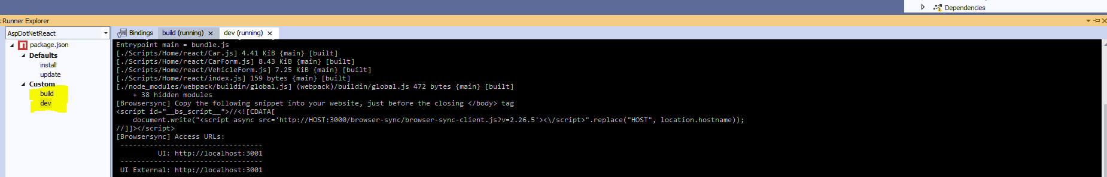

1. Run the code and in browser press F12 and right click on the refresh icon and click on refresh cache and hard reload option.

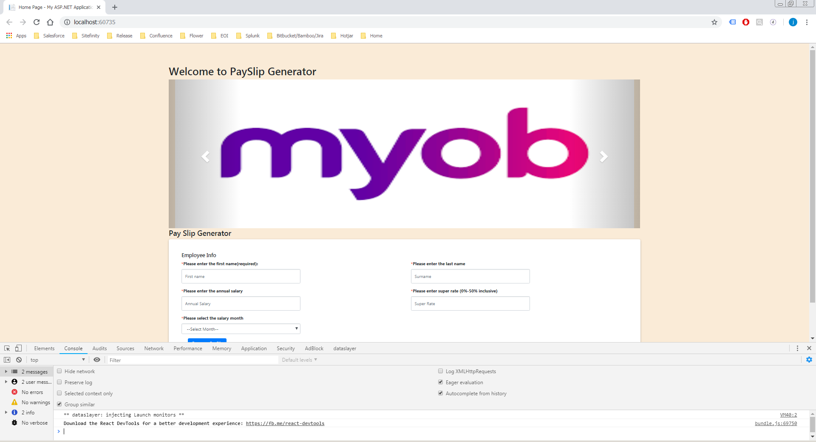

1. Yipee!!! That’s it .Application should run as expected.

**Screenshots:**

1. On load below screen will show up.

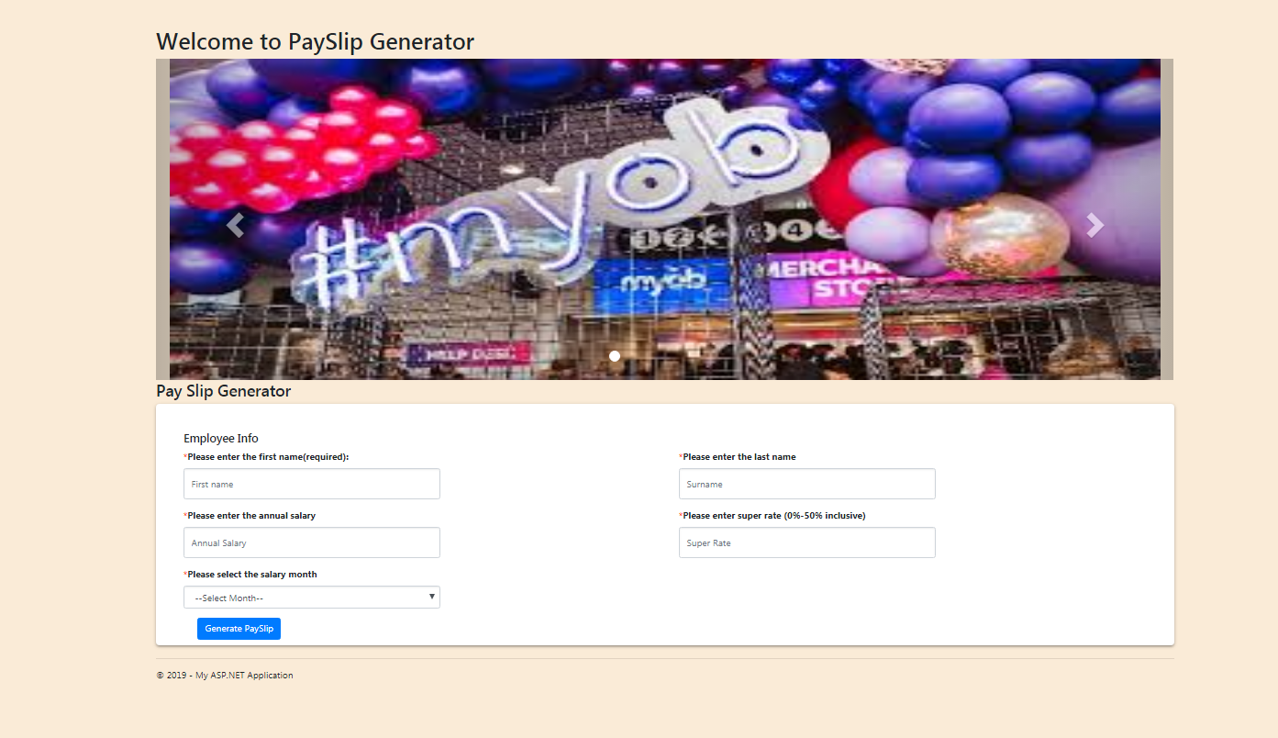

1. Enter the details and click ‘Generate slip’ button. On click of button customizable table structure will display showing the payslip of an employee.

